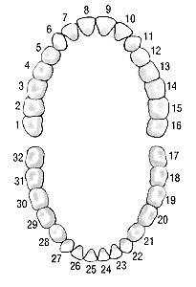
Upper Jaw – No 8 tooth missing for last 25 years and wearing a pallet– According to Australian dentist need Bone grafting before implant. Any solution without bone grafting?
Upper Jaw – No 14 tooth missing for last 2 years – Need an implant.
Lower Jaw – No 30 tooth missing for a long time. Need an implant.
Lower Jaw – No tooth no 20, 28 and 29 – really bad and very sensitive need removing and fixing with implants or filling and covering with crowns.
Lower Jaw – tooth no 21 – Root canal done 25 years ago with a crown. Crown cracked and need replacement.
6 Implants and 7 crowns
In recent years noted that wear of the edges of the teeth resulting in thinning and chipping of the enamel surface. Also, most of the teeth have undergone some sort of filling.
Is it possible and advisable to restore the visible teeth with porcelain crowns to normal shapes and same time achieving a smile design.
In that case additional 16 crowns.

- Please provide an approximate cost
- Minimum time I need to be there – number of days in one period
- Is one period enough or need to revisit, say after 3 months?
- Around 13th of March suitable – Need to have the availability of the best doctor providing individual task.
- Any suggestion or better alternative to achieve what I am looking for.

Photos next page

