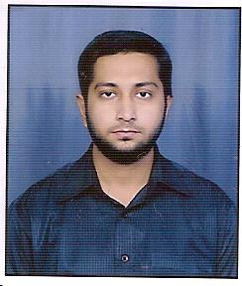

Name - DR. MOHD ZAKIULLAH

Contact no. - 09347670015

E-mail id – drzaki00@gmail.com

  - OBJECTIVE:
Seeking an entry level position in a leading dental hospital or clinic in order to improve my dental career.

  - EDUCATION

Bachelors in Dental Surgery from Rajiv Gandhi university of health sciences, Bangalore
Qualifying year- July 2012

  - WORK EXPERIENCE

-Currently running a private dental clinic in Hyderabad.

  - SPECIALISED SKILLS

-Excellent diagnostic skills using clinical knowledge and x-rays
-Excellent theoretical knowledge
-Excellent verbal and written communication skills
-Good knowledge of clinical practices and protocols
-Ability to handle different types of patients
-Flexible and adaptable
-Extremely motivated towards career

  - INTERNSHIP

-Conducted Health Education
-Involved various types of cases which included:
- Root canal treatment and Digital Radiography
- Dental cleanings
- Composites, Amalgam Restorative fillings and Complete Dentures.
- Fixed Partial dentures
- Oral Prophylaxis
- Surgical extractions, clinical crown lengthening surgeries.

  - ACHEIVEMENTS
-certificate of participation in Insight in ceramese for clinical practice conducted by dilsukhnagar dental association and certified by AP state dental council.

PERSONAL PROFILE
Date of Birth – 28-06-1989
Gender - male
Nationality - Indian
Hobbies - shuttle, Travelling, and Hoteling.

